Project

Game Design Document

Draft 1

By Caroline Percy &

Danial Hakim Nor Azman

5 / 10 / 2021

Alien Escape

Table of Contents

**1.** Overview 3

**1.** **The Elevator Pitch / High Concept** 3

**2.** **Theme, Setting and Genre** 3

**3.** **Player Experience Goals** 3

**4.** **View** 3

**5.** **Targeted platform(s)** 4

**6.** **Technical requirements(s)** 4

**2.** GamePlay 4

**1.** **The First Minute (60 seconds of play)** 4

**2.** **Game progression** 4

**3.** **Level progression** 5

**4.** **Objectives/Victory Conditions** 5

1. Overview
   1. **The Elevator Pitch / High Concept**

Alien Escape is a two-dimensional horror-style game where the player races to escape a space ship before they are found by the alien.

* 1. **Theme, Setting and Genre**

The game will be on an alien ship and it will be dark inside the ship.It will be a horror single player game.

* 1. **Player Experience Goals**

Player experience goals will be fear and tension, followed by relief - whether it's escaping the alien for a moment, or being scared by it.

* 1. **View**

The game will be a top down view game and the camera will be fixed in height.The camera will follow the player around, keeping the player in the middle of the screen at all times.

* 1. **Targeted platform(s)**

Windows 8 or later. 1024 x 800 resolution expected.

* 1. **Technical requirements(s)**

The hardware we will be using for this project is personal laptops and college computers.We will be using SFML and visual studio as our software to develop the game.As for now, we are not using any game engine. The game is a single player offline horror game so it does not have any network requirement.

1. GamePlay
   1. **The First Minute (60 seconds of play)**

After a title screen, the player is presented with a top down view of a man - the player character - in a small, dark room. The player will be shown a text saying “press ‘F’ to turn on your light.”. When the player presses F, a 45 degree cone appears in front of the man, starting from him and expanding out. It will change angle as the player moves the mouse around.

The player is then shown a text saying “Use ‘WASD’ to move.” At this point, the player can move around, and explore the room. They will eventually find a locked door and a dead body. The player will be shown the left mouse button when they walk over the corpse, which allows them to investigate and pick up items. They find a key on the body, which fits the locked door.

Once the door is opened, the player can explore more of the ship, at the cost of avoiding the alien.

* 1. **Game progression**

1. The player will be given certain tasks to do and as the player will get keys or items that allow them to go to the next area. The player can always go back to the areas they have unlocked to hide or to find other items later on.
2. The tasks will be harder as the player progresses. At the start of the game, the task will be as simple as picking up the item in this room, then grow to looking for parts to assemble the item in order to use it.The alien will also be more sensitive to sounds and will appear more.
3. The goal for the player is to escape the ship, the reward that will be given out is the item that the player gets to use after finishing their tasks.  
   1. **Level Progression**

level progression would be slowly but surely unlocking each room of the ship, and survive the alien patrolling around while doing so. The overall objective would be to escape the ship before the alien catches you, but the moment-to-moment objective would be to find the next key, or survive the alien stalking you nearby.

* 1. **Objectives/Victory Conditions**

The objective of the game is to stay hidden from the alien while finding a way to escape the ship .Player can move slower to have less noise or go faster with the risk of being found out by the alien.The choice is up to the player.The alien cannot be kill so player could either run away or hide.The victory condition is filled when the player has escaped the ship without being caught by the alien.

1. Features
2. Movement of the player. (sneak, walk, run)
   1. How fast is the player when he’s walking? 1 m per second.
   2. How fast is the player when he’s running? 1.5 m per second.
   3. How fast is the player when he’s sneaking? 0.75 m per second.
   4. Can the player sneak/walk/run when they’re out of stamina? Yes/Yes/No
   5. How long can the player run for? 5 seconds.
   6. How long would it take for stamina to fully recover? 3 seconds.
   7. How quickly does the player go from sneaking to walking to running? Instantly.
   8. Will the player stop when they hit a wall? Yes.
3. Grid System.
   1. How big is one square of the grid? The size of the player.
   2. What will the grid squares contain? the grid will contain walls, floors, furniture, everything in terms of the layout of the space ships
   3. Around what size is the map in squares? 100 x 100
   4. Around what size is a ship in squares? 25 x 25
4. Pathfinding of the alien.
   1. What pathfinding system are we using? A* pathfinding.
5. Player Mission.
   1. How does the player progress? by doing the missions until they escape
   2. Is there guidance for the player? Yes, on the map (EX. Find the control panel : Ship A.)
   3. How does player fail? by getting caught by the alien
   4. What is the story? (in progress) the player is trapped on a ship with an alien, who has killed all other survivors. They must sneak past the alien, get the items necessary to unlock their way to the escape pod, and leave before getting caught.
   5. What is an estimated number of missions? 10 (excluding tutorial)
6. Movement of the alien.
   1. How fast is the player when he’s patrolling? 1 m per second.
   2. How fast is the player when he’s chasing? 2 m per second.
   3. Can he pass through walls? No.
   4. What range does the alien detect the player? The alien has a 15 degrees vision cone with a length of 15, and a peripheral vision cone of 2m in a semi-circle in front of him. If the player vision cones, then the alien knows the player’s position.
   5. Can he go through doors? Yes.
   6. How does the alien patrol? The alien has a series of coordinates it can choose randomly. Once the coordinate is chosen, the alien will pathfind his way over to it.
   7. When does he start patrolling? When the player finishes the tutorial
   8. When does he start chasing? When he knows the player’s position.
   9. When does he stop chasing? When the player leaves the vision cone, it will enter a confused state, and go to and look around the player’s last seen position. if it doesn’t spot the player after 5s of being in the confused state, it will go back to patrolling.
   10. Where can he go? Everywhere, as soon as the player leaves the starting room
7. Sounds (ambient, alien, sfx)
   1. Will the alien make sound? yes. growling if its nearby, heavy footsteps when moving, shrieks when it spots you
   2. Will the player make sounds? yes. Running, opening doors, using items like noisemakers, alien scanner
   3. Will items make sound? Most items will make sounds, like the scanner will beep. The only one that doesn't make sound is the book.
   4. Will the environment make sound? Yes, opening the doors to other ships and other rooms will make noise. The environment will also have ambient noises to mess with the player.
   5. Can the alien/player hear each other when on different ships? Depends on the noise. There will be three types of noise volume - one where the sound can be heard only if you’re on the same ship, one where the sound can reach you if you’re on a nearby ship, and one where the sound can be heard from all around the station.
8. items and inventory.
   1. How many items can the inventory hold? 4 slots
   2. Does it need to be organised in order to carry more things? No
   3. How does the player navigate the inventory? WASD keys, and I to close it again.
   4. How does the player use the items in the inventory? they can equip an item by selecting it by navigating, and E to equip the item.
   5. Will the game pause when the inventory is open? No
   6. What are the items that are in the game? smoke bomb, noisemaker, scanner, book.
9. UI system (map, stamina, inventory, menu, win/lose screens)
   1. Where is stamina displayed? Bottom left, it will be a small green bar that will go from green, to yellow, to red, to empty, as the stamina is used up. The colour will go in the opposite order when the stamina is refilling.
   2. Where is the mission displayed? On the map menu.
   3. Where is the minimap displayed? top right
   4. what can the player see on the minimap? the current spaceship they are on (the rooms layout, and which spaceships they connect to.)
   5. how to access map? M key
   6. where is main map displayed? All across the screen
   7. is the map transparent? yes
   8. Can the player see the four ships during gameplay? No, they can only see one, and only the room they are in is visible, the rest are dark.
   9. What does the main map show? All four spaceships, their names and how they're connected to each other.

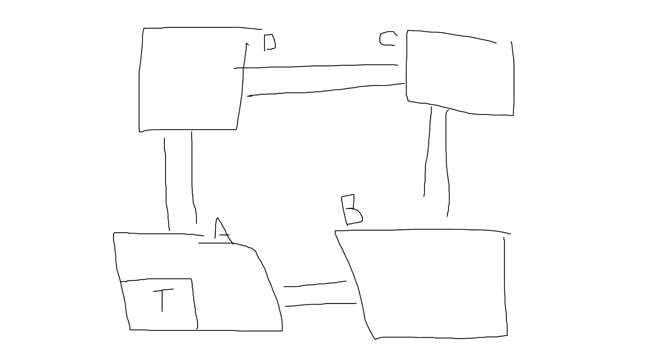

* 1. how to open inventory? I key
  2. Is the inventory transparent? yes
  3. When does the menu appear? At the start of the game
  4. When does the win window appear? when the player has escaped the ships
  5. When does the lose window appear? When they are killed by the alien

1. throw/use objects.
   1. How do you use/throw objects? E key
   2. Which items are thrown? Smoke bomb and noisemaker
   3. Which items are used? the scanner and the books
   4. How many items can you use at once? 1
   5. Which items are consumable? the noise maker and the smoke bomb
   6. How many noise makers / smoke bombs can the player carry at once? 2-3
   7. How many noise makers / smoke bombs will appear on the map? (approx) 5
   8. How do you equip an item to be used? Select it on the item menu, and press E
   9. Do multiples of the same item stack together? Yes
2. Lighting system
   1. Will there be a flashlight? Yes
   2. Will the flashlight be a part of the inventory? No
   3. How far will the flashlight light up? around 3 in front, and two in width by the end of the cone.
   4. Does the flashlight have a battery? No
   5. Are there other lights on the ship? Yes, through overhead lights, but they are sparse.
   6. How do you turn the flashlight on/off? F key
3. Quick time events.
   1. What keys would we be using? numbers, which will be handed out as you as you explore the spaceship
   2. What happens if you put in the wrong code, or you take too long? A loud alarm goes off, notifying the alien of where you are.
   3. What happens if you succeed? No noise happens, and you can move to the next ship.
4. Particle system.
   1. What particles will be in the game? Smoke, fire, sparks from technology, candlelight from a noisemaker
   2. Will the particles be visible in the dark? Yes
   3. Will the player be able to see particles outside their current room? No
5. Alien/player character choice.
   1. How many unique aliens will there be? 3
   2. How would the aliens differ? Speed, visibility, hearing, sound
   3. How many unique humans will there be? 3
   4. How would humans differ? Speed, visibility (different flashlights), inventory slots, get perks in quick time events, and looks.
   5. How would the player choose alien/human? The player can choose a human at the main menu, under character selection. the player can’t choose an alien, it is random each time.